**HDP Administration - Core Lab Guide**

**Lab-2: Managing Ambari Users and Groups**

Objective: To manage Ambari users, groups, and permissions in the Ambari Web UI

[root@golden-node1 ~]# cat /etc/passwd

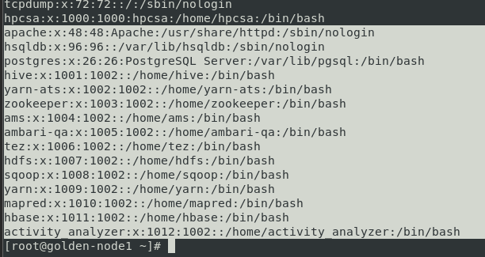

Go to Ambari Dashboard:

* 1. Click on Service Account

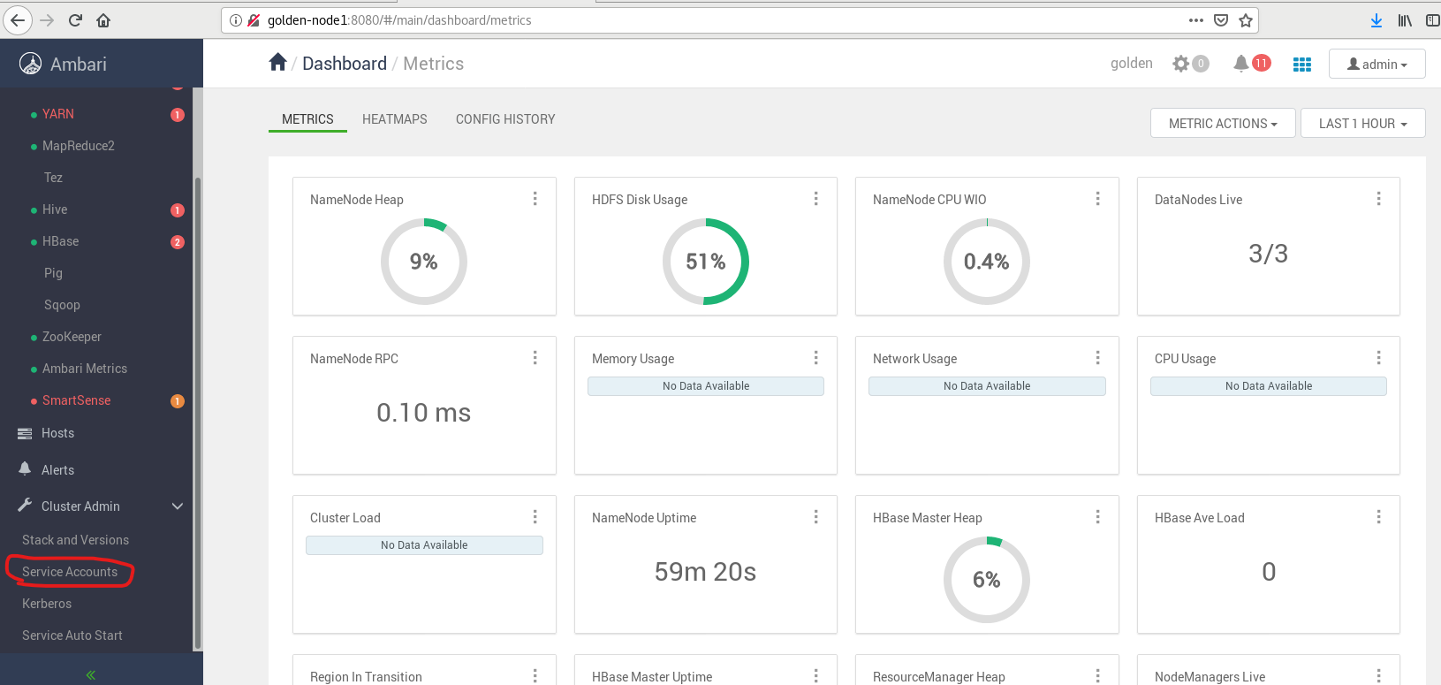

See Services which we have seen in /etc/passwd

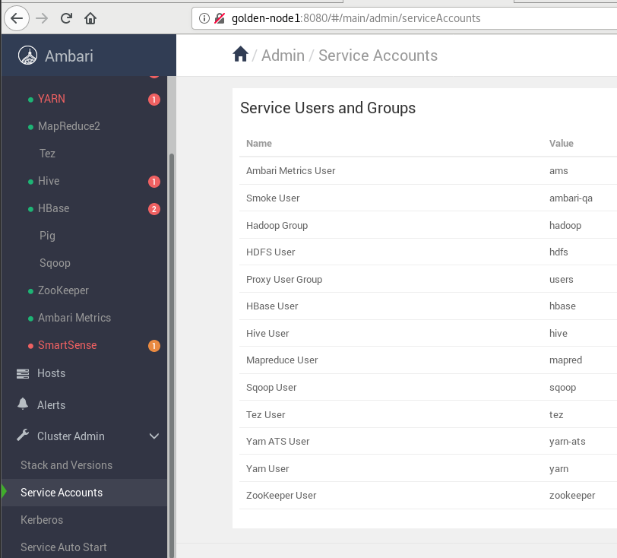

Now**, Adding Ambari User Account**

1. Click on Admin then Select Manage ambari

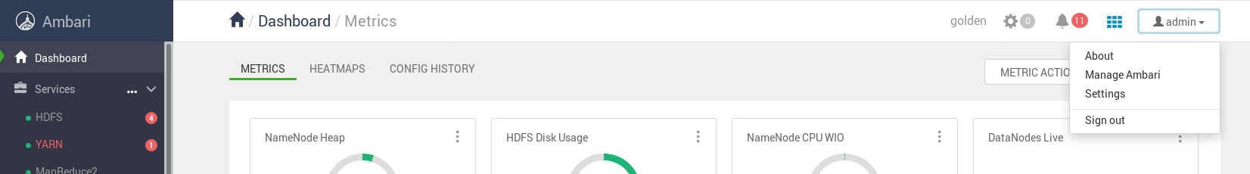

1. Click On Users

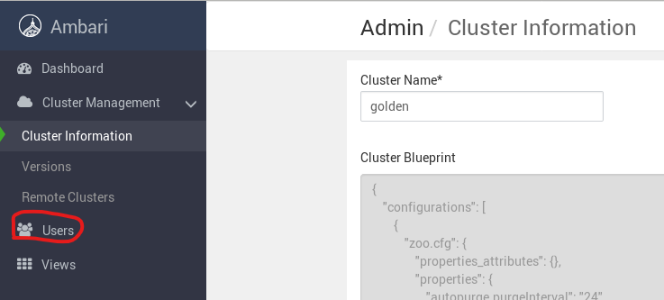

1. Click on Add Users

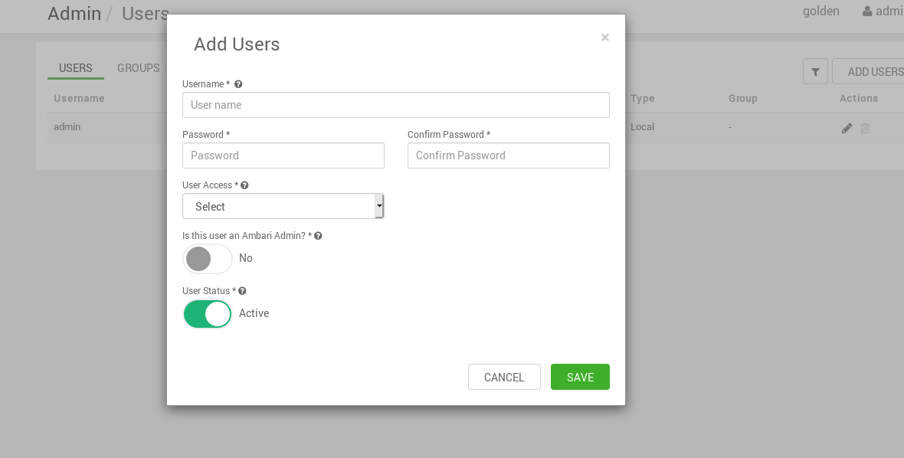

1. Create a User of Name: npuser, password: hpcsa and User Access: None

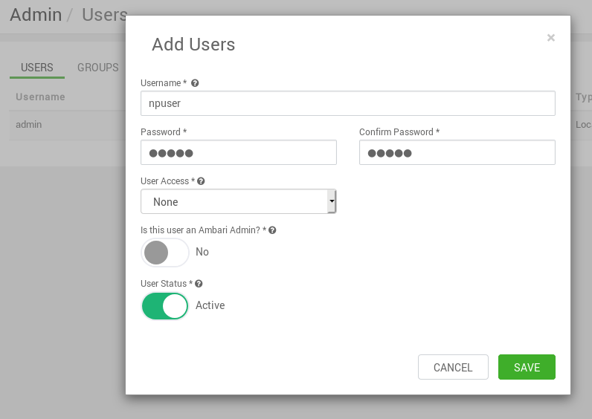

1. Create Other Users and Assign Roles them

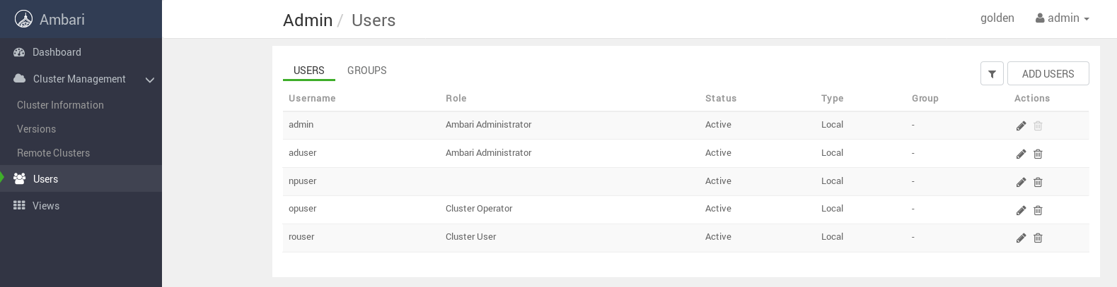

1. Logout and Login from “npuser”

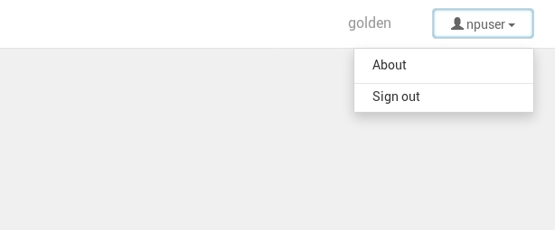

1. Logout from “npuser” and Login from “rouser” user

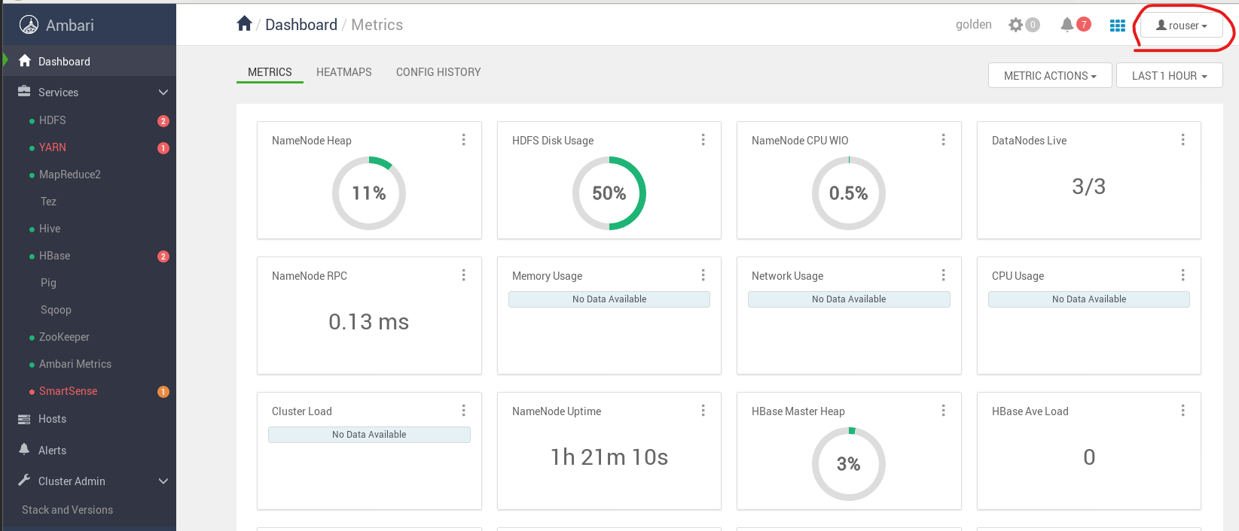

Go to HDFS 🡪 Not able to see Service Account button

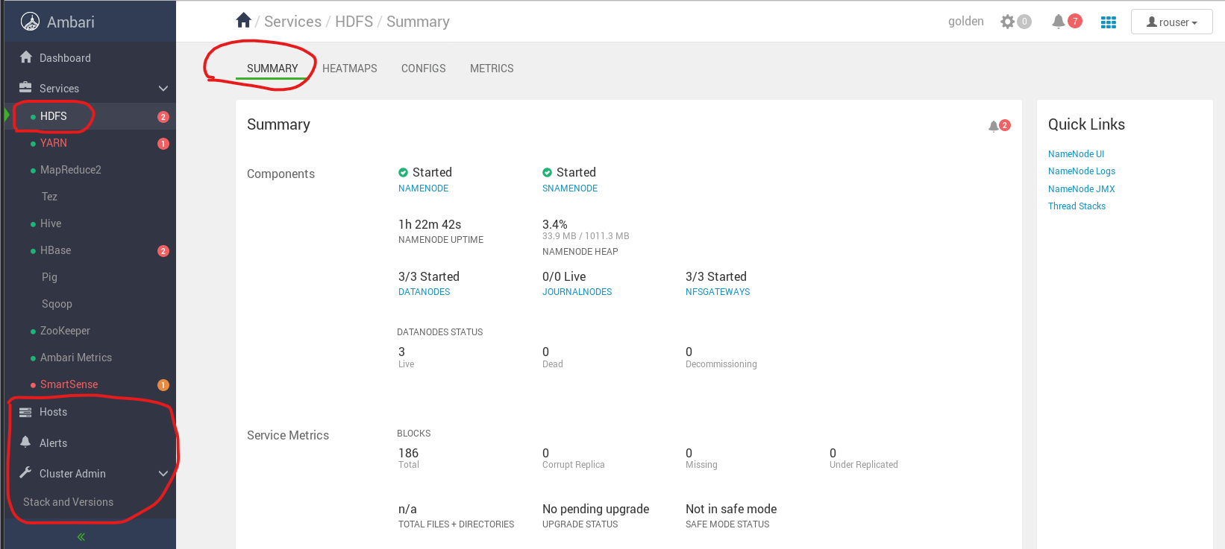

Go to Hosts 🡪 Not able to see Action Button

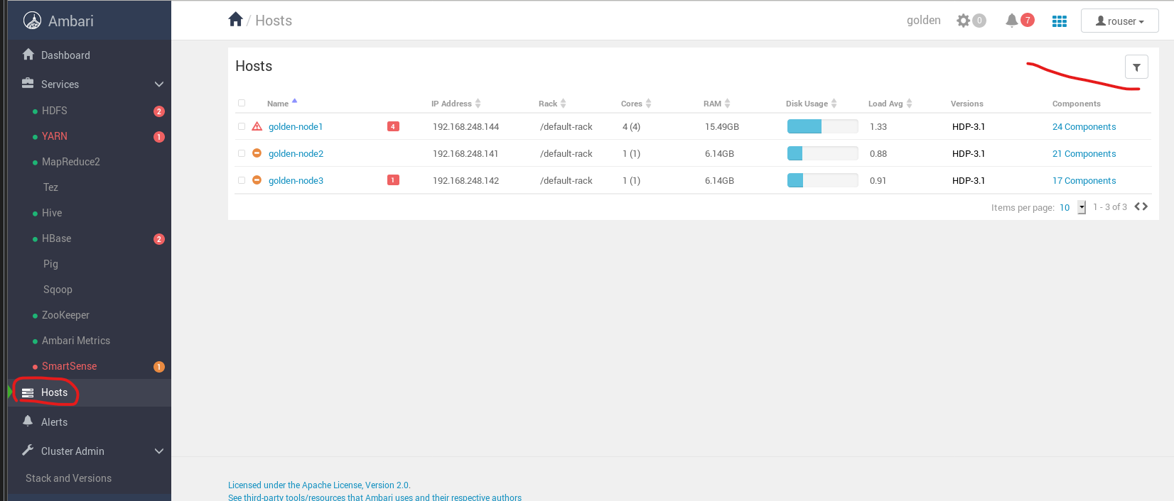

Go to Alerts 🡪 Not able to See Action Button

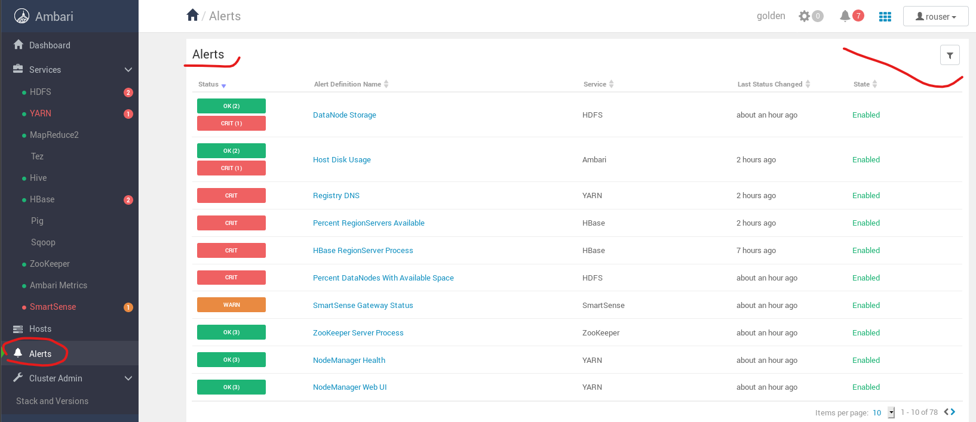

1. Logout from “rouser” user and Login From “opuser” user

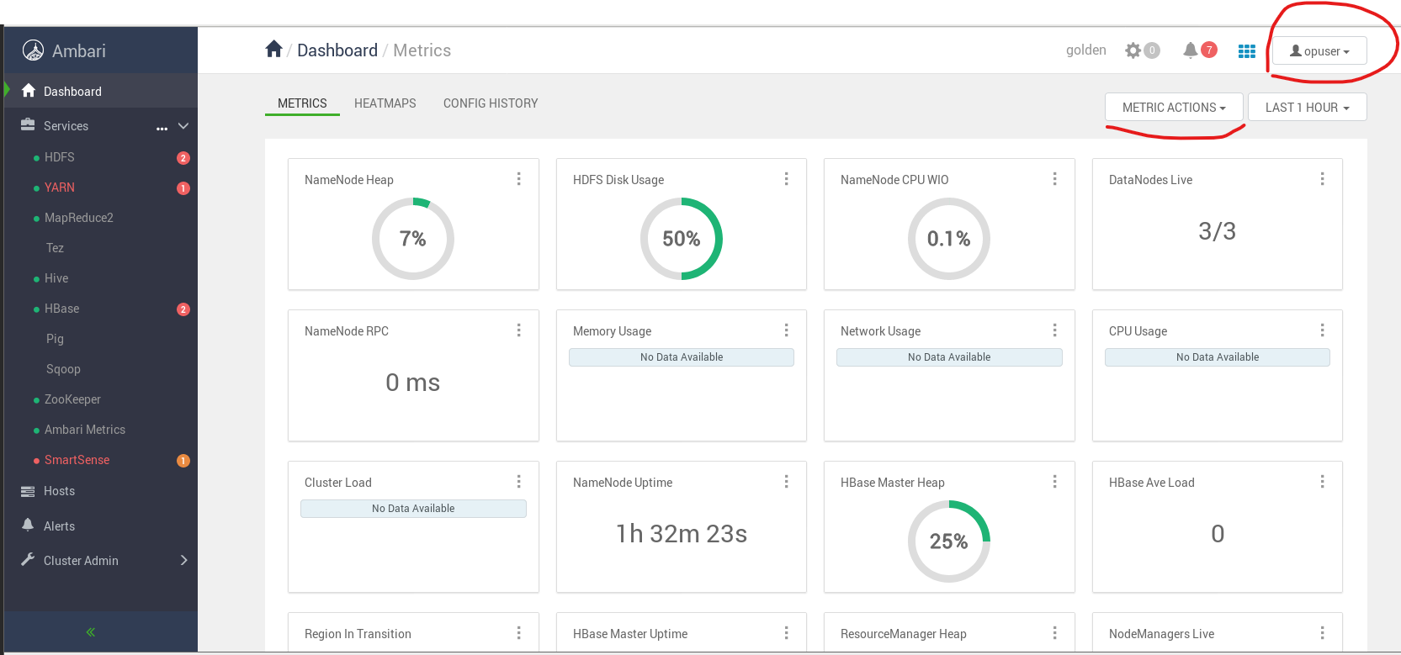

Go to HDFS 🡪 Able to See action Button

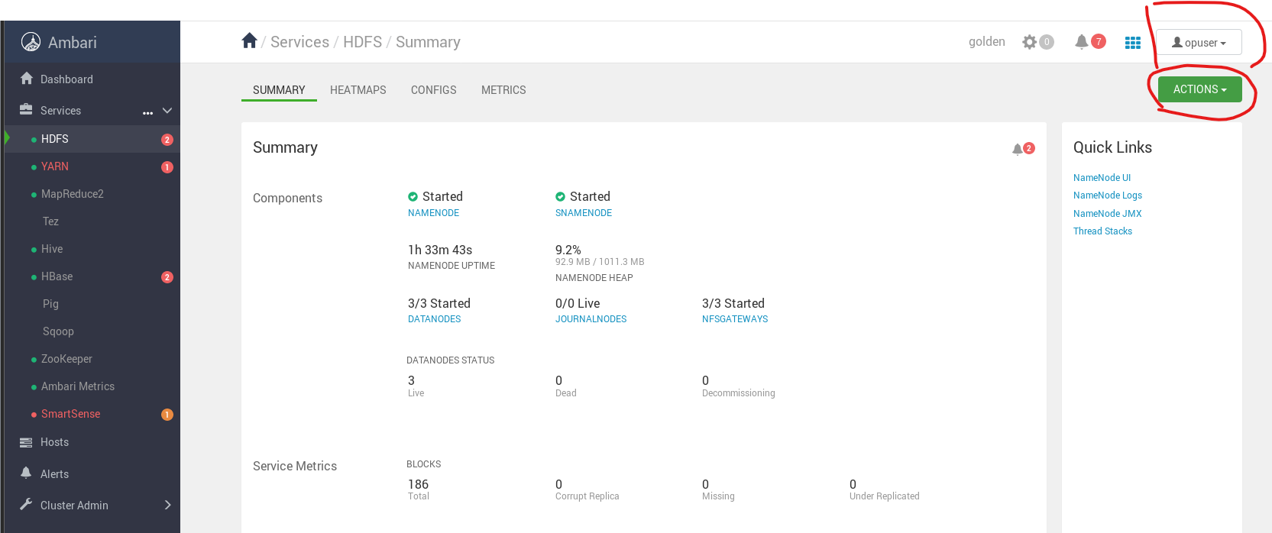

Go to Hosts 🡪 Able to see Action Button but, Not able to see Service Action Button

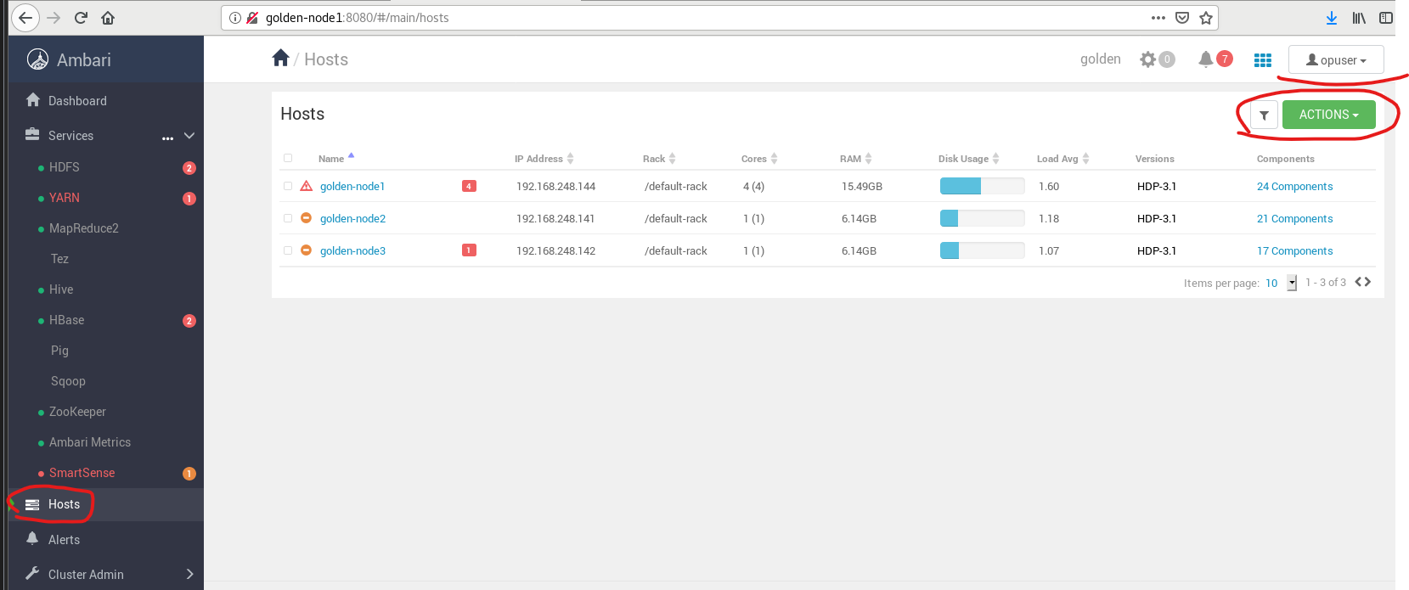

Go to Alerts 🡪 Not able to see Action Button

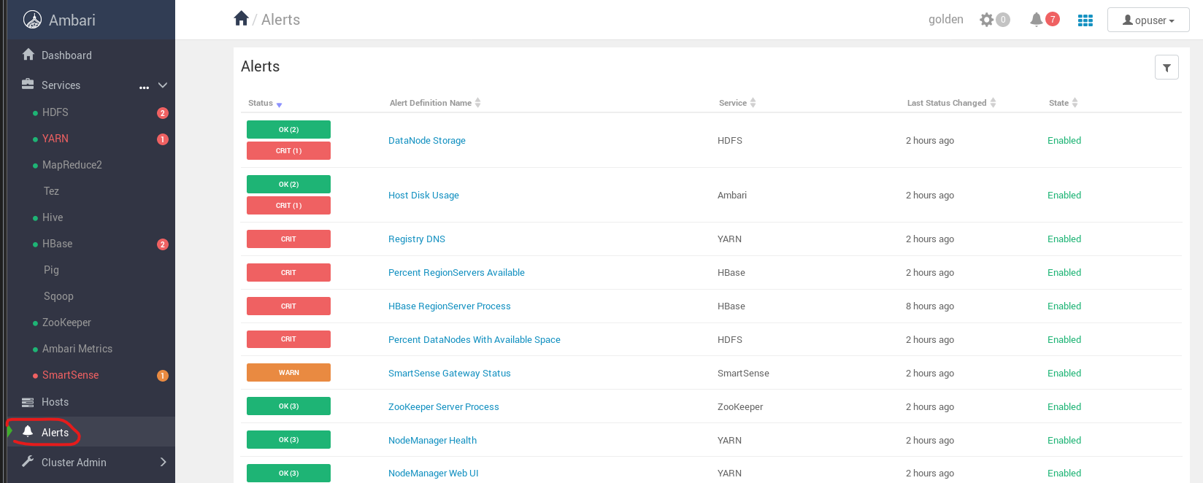

1. Logout form “opuser” and Login from “aduser” user

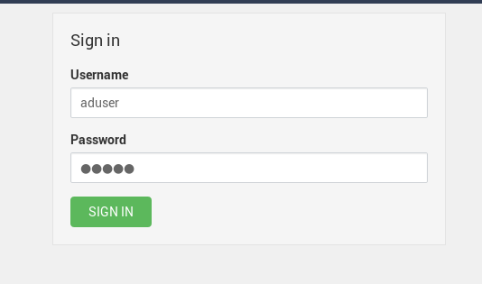

Go to HDFS 🡪 Able to see Action and Service Account Button

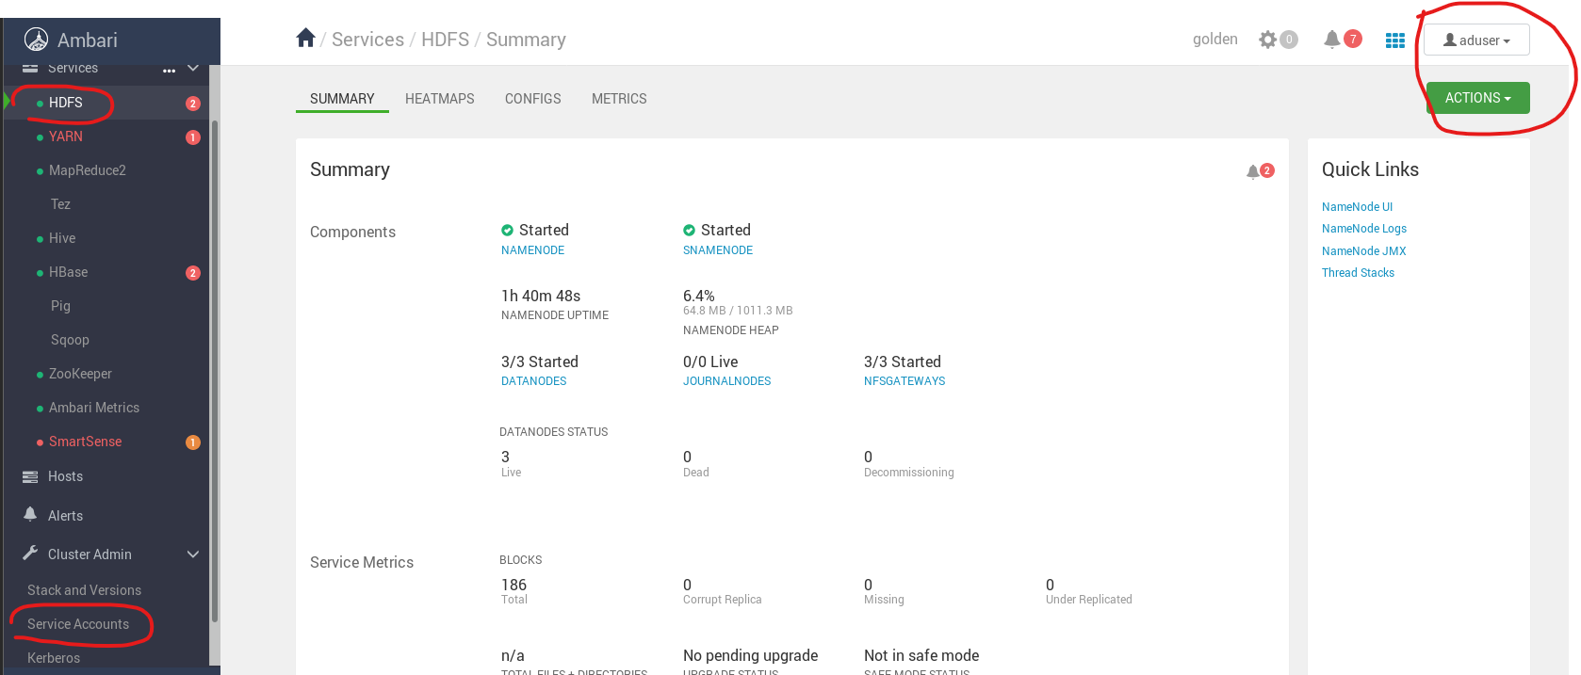 Go to Hosts 🡪 Able to See Action Button

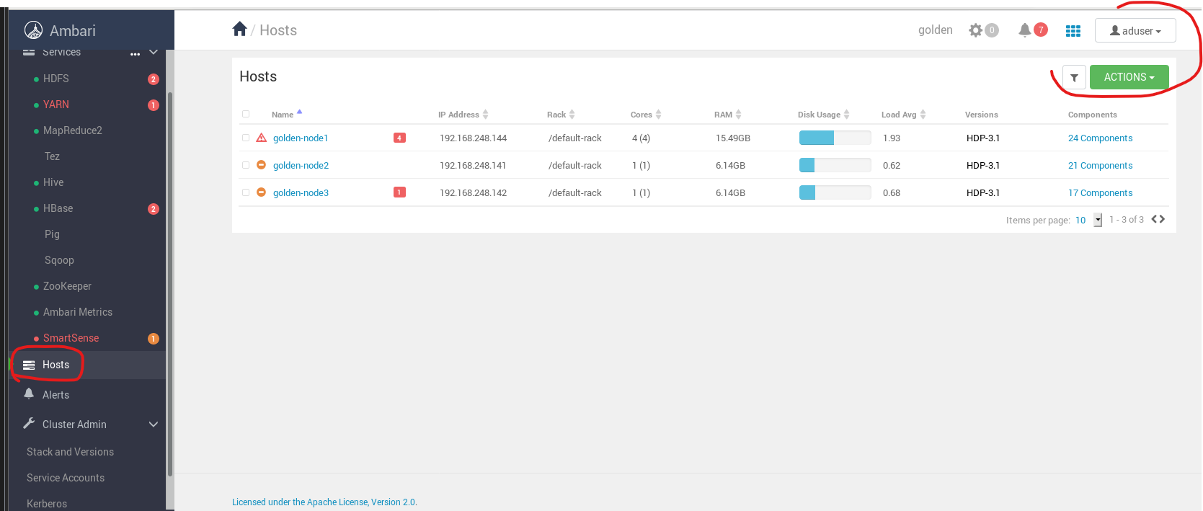

Go to Alerts 🡪 Able to See Action Button

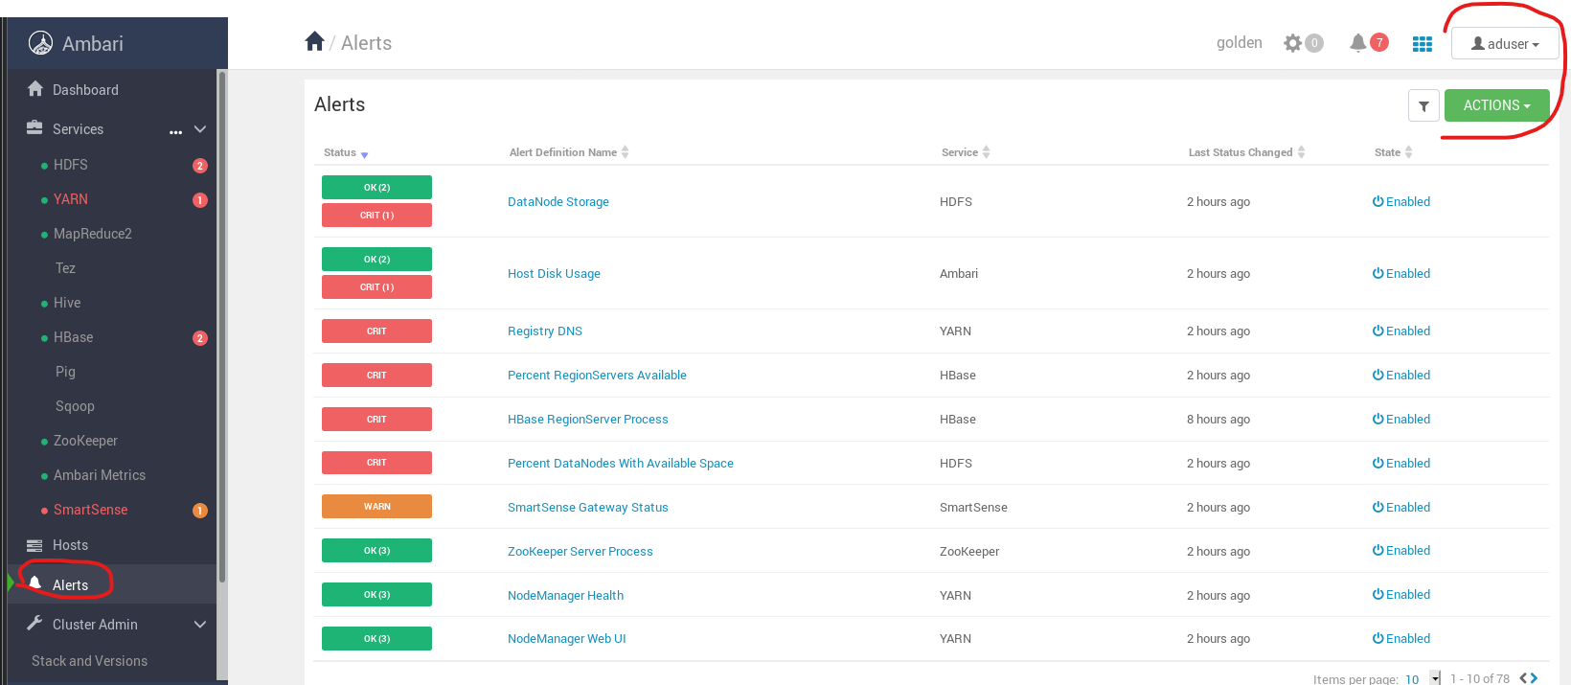

Click on “aduser” tab 🡪 Able to see Manage Ambari Option because which is only available to user accounts with admin permission

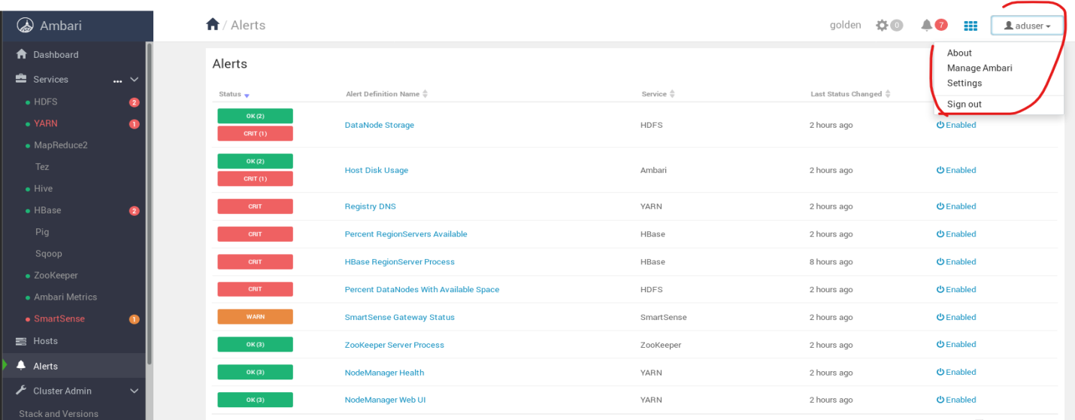

Select Manage Ambari from “aduser” account

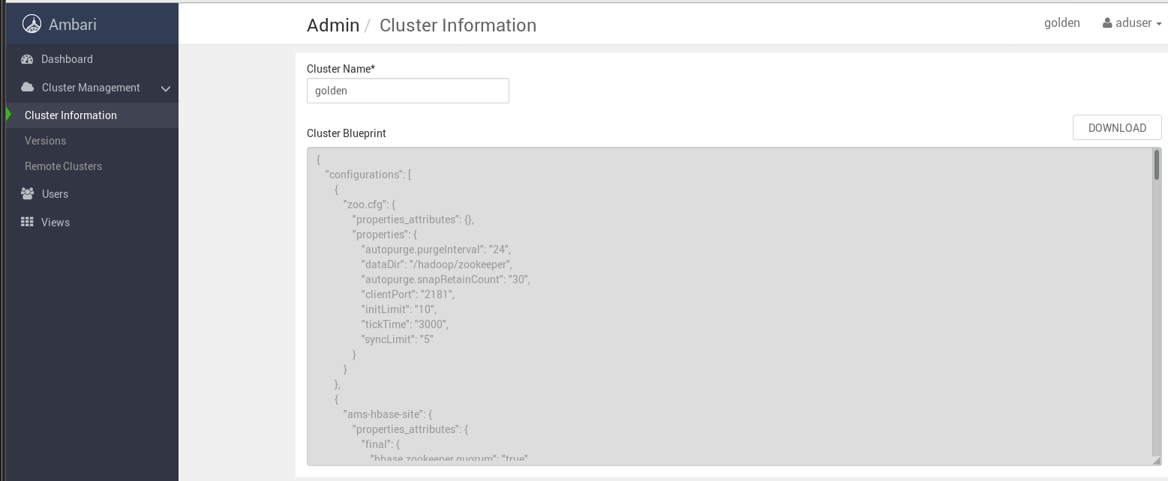

**Remain Logedin as “aduser”**

**Now, Create New Groups**

**Create a new Ambari group named “opgroup”, add the “npuser”, “rouser”, “opuser”, and “aduser” user accounts to the “opgroup” group, and assign it the group “operator permission”.**

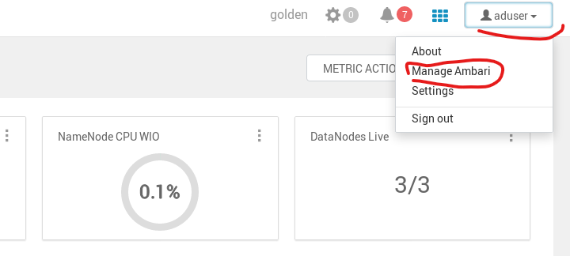

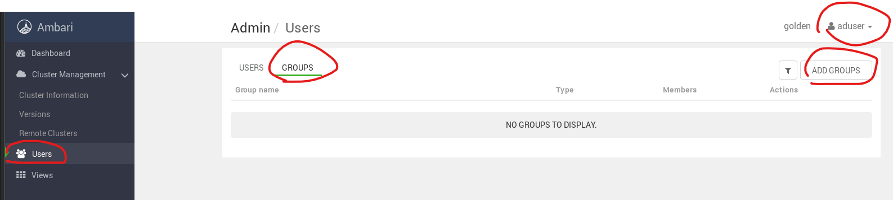

Group name: opgroup, Add Users to this Group: npuser, rouser, opuser, aduser and Group Access: Cluster Operator 🡪 Save

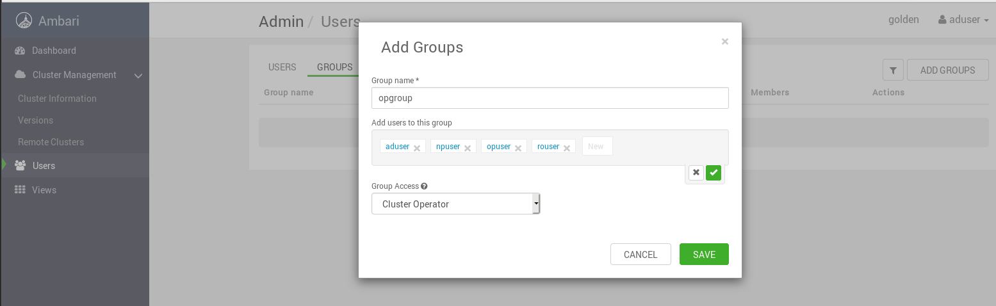

Now we Lost Manage ambari Option still, login as “aduser”

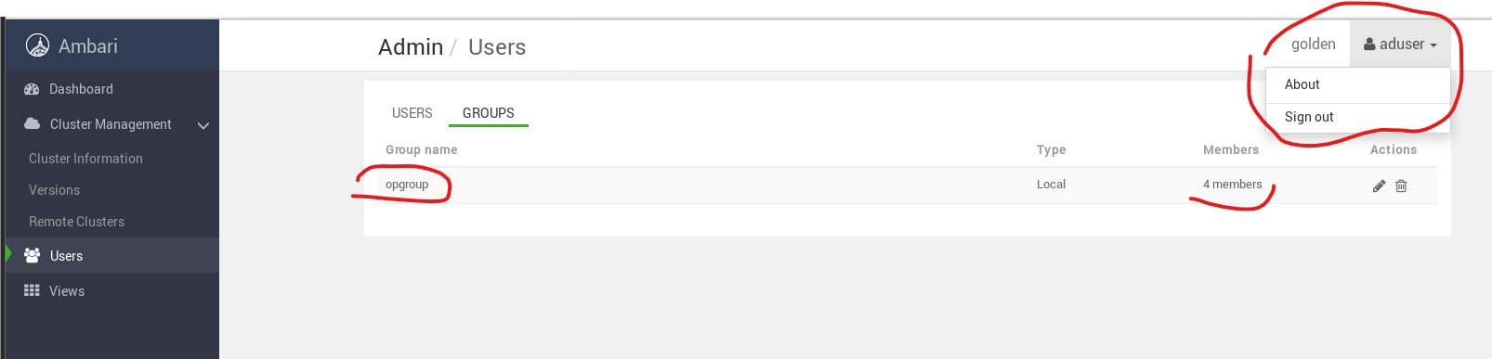

1. Logout from “aduser” account and Login from “npuser” account

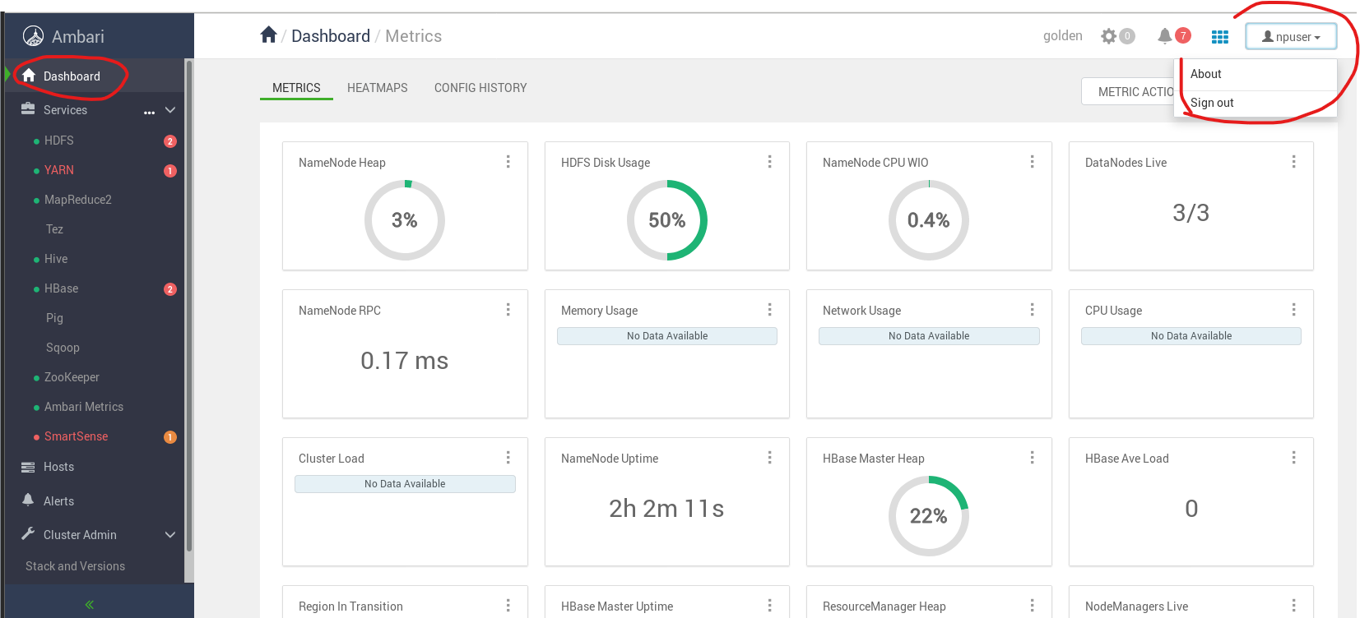

Go to HDFS 🡪 able to See Action Button but not able to see Service Action Button

